cyber_tech_society•Seuraa

Here are 15 Sites you can learn Coding for free:

* Codeacademy
* Treehouse
* Udemy
* Coursera
* Khan Academy
* W3Schools
* EdEX
* FreeCodeCamp
* Evanto tuts +
* Codeconquest
* Udacity
* Sololearn
* Code Avengers
* Learnenough

❤️🗨️↗️/📎

**3 486 tykkää tästä**

**cyber_tech_society** Monetize Your Knowledge With Courses 👩‍💻...lisää

Näytä kaikki 60 kommenttia

**arkkapoor_** Youtube

**skyblue_1704** The best way to learn something is to read a book… Yeah, it's true… When you learn from online courses the source code may misguide you. For example let us take example of comments in programming a website may only tel []

29.marraskuuta 2020•Näytä käännös

big_it_jobs•Seuraa

🖥️IT Professionals Page💻

📝 Inspiration | Motivation | IT Jobs Updates ✌️

📝 #Repost Most Informative Tech Post 📜

🥇Build Success Through Right Platform🥈🥉| 🥇🥈🥉

Most Popular Database

MySQL

PostgreSQL

SQL Server

SQLite

MongoDB

Redis

MariaDB

Oracle

Firebase

Elastic Search

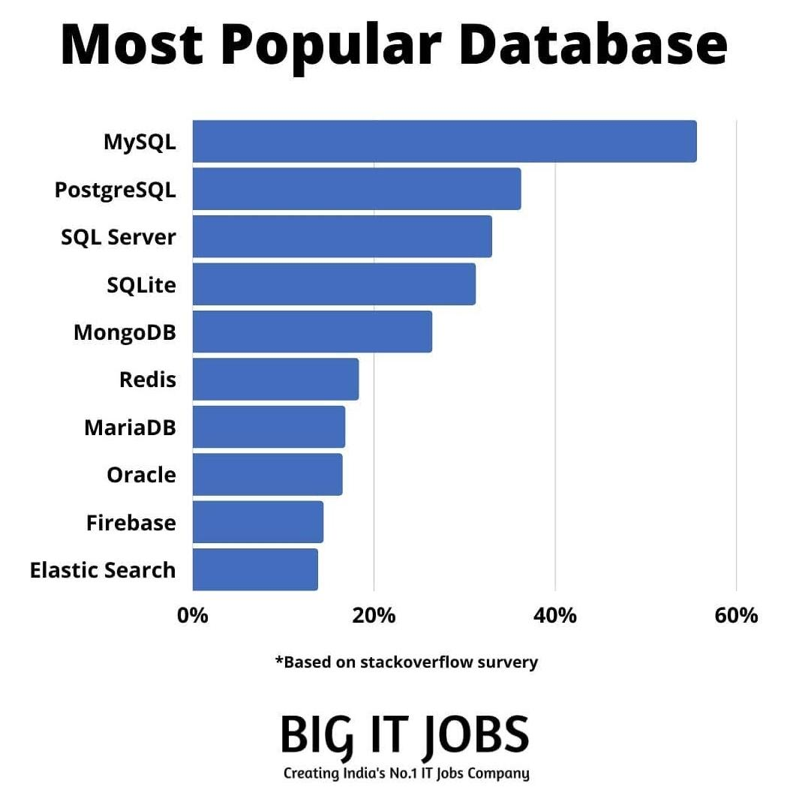

❤️🗨️↗️/📎

**846 tykkää tästä**

**big_it_jobs**☝️☝️Double TAP for more amazing post ✅

➖➖➖➖➖➖➖➖➖➖➖➖➖➖… lisää

Näytä kaikki 34 kommenttia

**big_it_jobs** @ogoaonoeosoh sorry?

**g_a_n2001** @big_it_jobs I mean are you working as database Administrator or in a related field ??

26. marraskuuta 2020•Näytä käännös

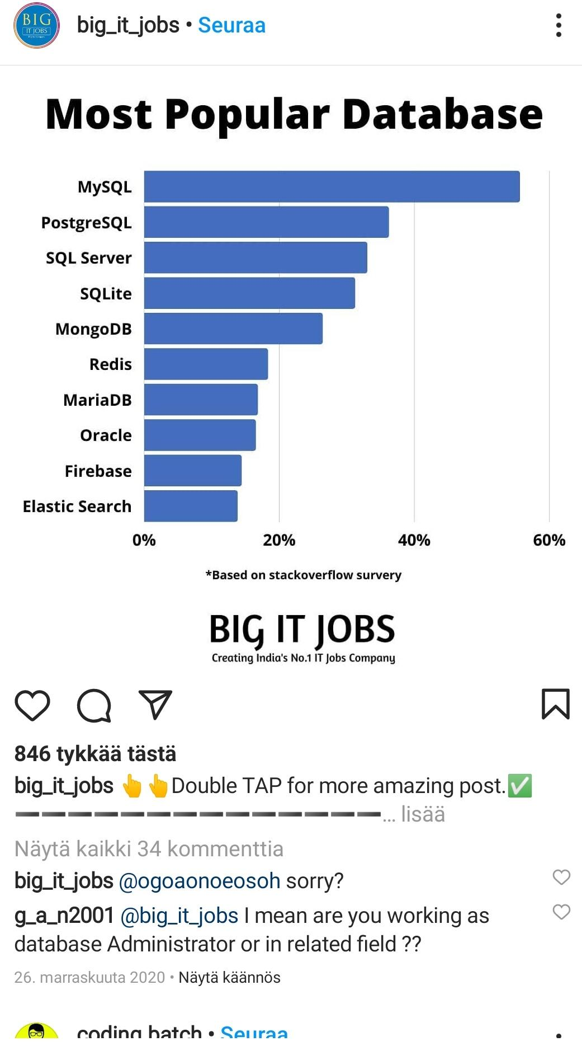

POPULAR DATABASES: MySQL. PostgreSQL. SQL Server. SQLite. MongoDB. Redis. MariaDB. Oracle. Firebase. Elastic Search.

MOST POPULAR DATABASES/ BASED ON STACKOVERFLOW SURVERY/ BIGITJOBS / SOURCES/

coding.batch•Seuraa

Web Developer | HTML CSS JS | Training

All about frontend development 👩‍💻

Projects/snippets/tips/resources 📺

Checkout reels for memes 🤪

Dm for Paid Promotions ✉️

Näytä käännös

[linktr.ee/coding.batch](https://linktr.ee/coding.batch)

HTML Cheatsheet pages in HTML5

🛡️

HTML Cheatsheet 1/

✅

HTML Cheatsheet 2/

Basic Tags 💻📖📑

<html> HTML Document

<head> Page information

<body> Page contents

<title> Name in the title bar

HTML Cheatsheet 3/

Formatting 📰

<p> Paragraph

<br> Line Break

<blockquote> Content in Quotes

<div> Page section

<span> Inline Section

HTML Cheatsheet 4/

Lists 🧾📋

<ul> Unordered list

<ol> Ordered list

<li> List item

<dl> Definition list

<dt> Definition term

<dd> Term description

HTML Cheatsheet 5/

Links 🖇️

<a href="url"> Page link

<a href="mailto"> E-mail link

<a href="name"> Anchor

<a href="#name"> Link to anchor

HTML Cheatsheet 6/

Forms 📃📝

<form> Form

<select> Dropdown box

<textarea> Large input text

<input type="checkbox"> Checkbox

<input type="radio"> Radio button

<input type="text"> Text input

<input type="submit"> Submit button

<input type="reset"> Reset button

HTML Cheat Sheet 7/

🤔💬📨

VISIT PROFILE FOR MORE

GET COMPLETE HTML CHEATSHEET **sheet**

HTML Cheatsheet pages

✅

HTML Cheatsheet 1/8

💻

📖

📑

HTML Cheatsheet 2/8

Basic Tags

📰

HTML Cheatsheet 3/8

Formatting

🧾

📋

HTML Cheatsheet 4/8

Lists

🖇️

HTML Cheatsheet 5/8

Links

📃

📝

HTML Cheatsheet 6/8

Forms

🤔

💬

📨

HTML Cheatsheet 7/8

🤔💬

📨

💬

📨

HTML Cheatsheet 7/8

HTML Cheatsheet 8/8

🤔💬

📃📝🤔

💬📃📝🤔

📨

🤔

💬

🛡️

HTML Cheatsheet 8/8

Turn on post notification💬

Presented by:-@coding.batch

Learn web development

https://github.com/smthari coding batch

Share ❤️ Like Comment 🗨️

Save for later 🔰🔗📦

Share

❤️ Like

🗨️ Comment

coding.batch•Seuraa

Mumbai

Web Developer | HTML CSS JS |

Training

All about frontend development 👩‍💻

Projects/snippets/tips/resources 📺

Checkout reels for memes 🤪

Dm for Paid Promotions ✉️

Näytä käännös

<https://github.com/smthari>

<https://t.me/coding_batch>

<https://linktr.ee/coding.batch>

Share ❤️ LikeShare CommentShare 🗨️

Share ❤️ LikeShare 🗨️ CommentShare

Save for later 📦🔗🔰CommentShare

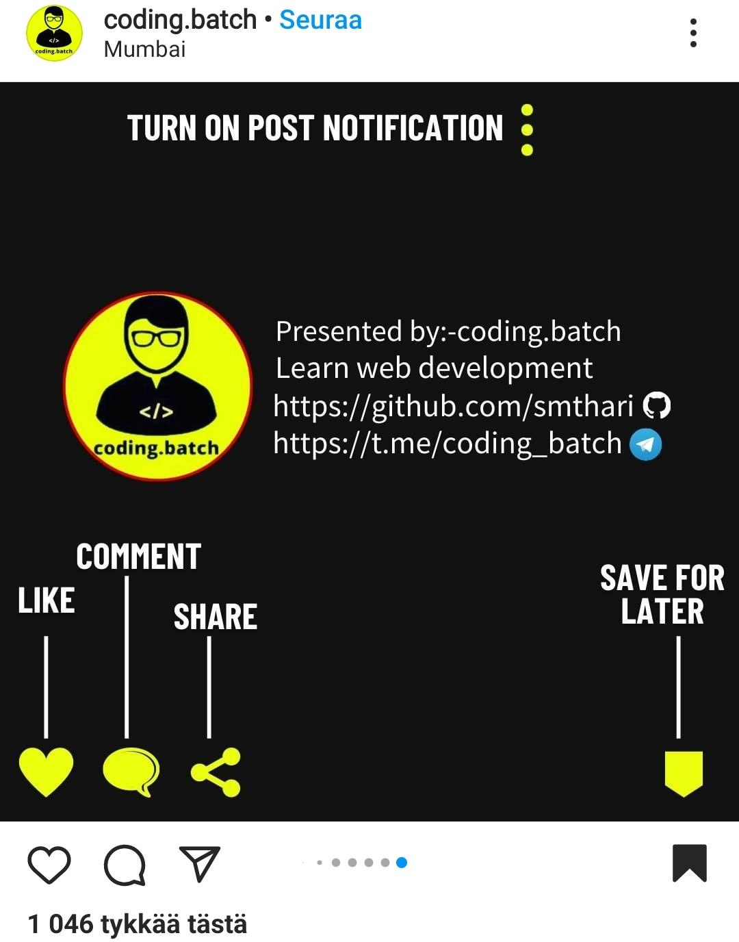

cyber_tech_society: 3486

coding.batch: 1046

<https://www.instagram.com/p/CII4AhGIm70/?igshid=1l1vr3iwda32k> remove

coding.batch: 1046

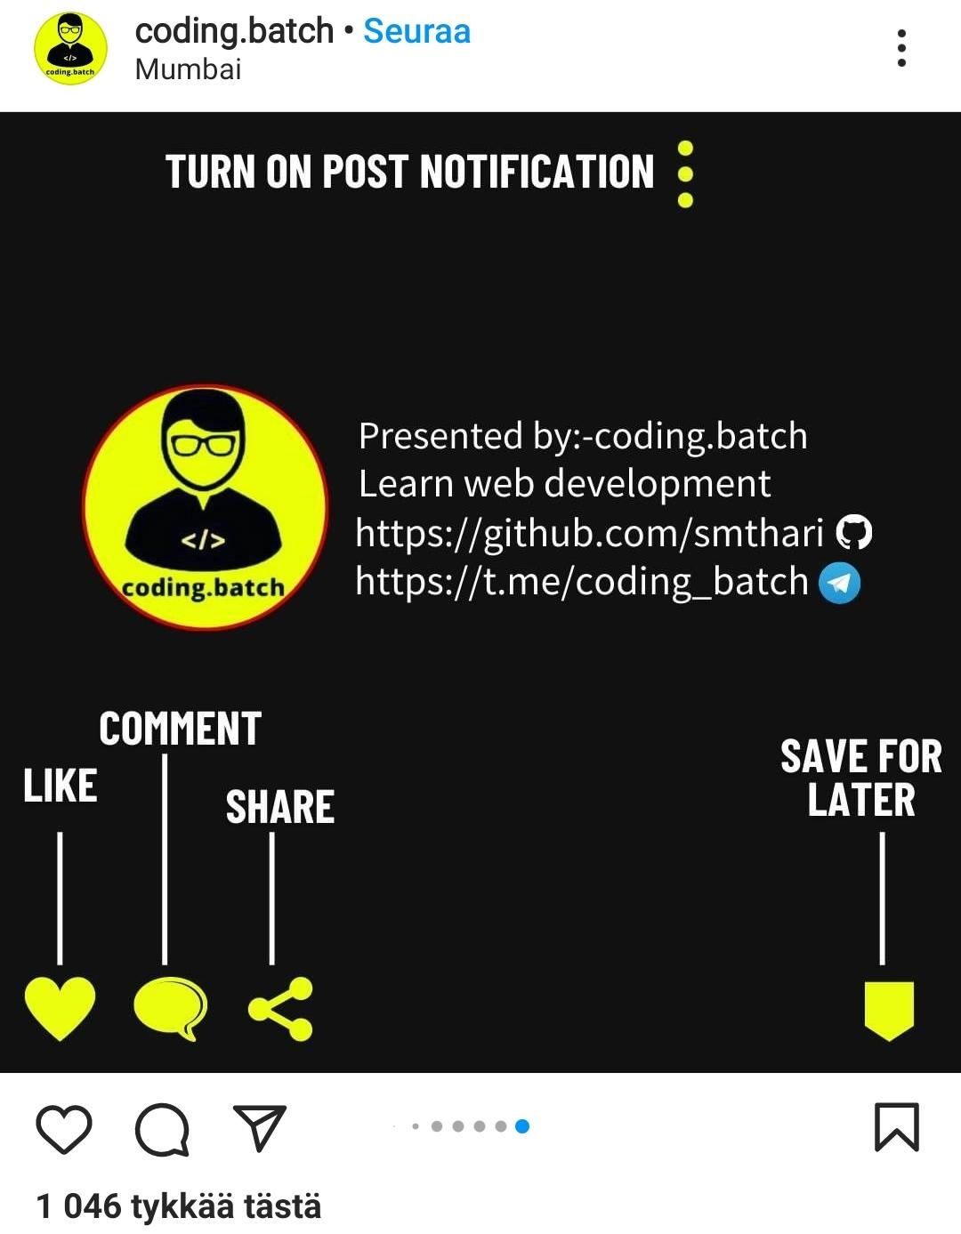

❤️🗨️↗️/📎

**1 046 tykkää tästä**

coding.batch: 1 046

big_it_jobs: 846

cyber_tech_society: 3446

big_it_jobs•Seuraa

🖥️IT Professionals Page💻

📎 Inspiration | Motivation | IT Jobs Updates ✌️

📎 #Repost Most Informative Tech Post 📜

🥇Build Success Through Right Platform 🥇

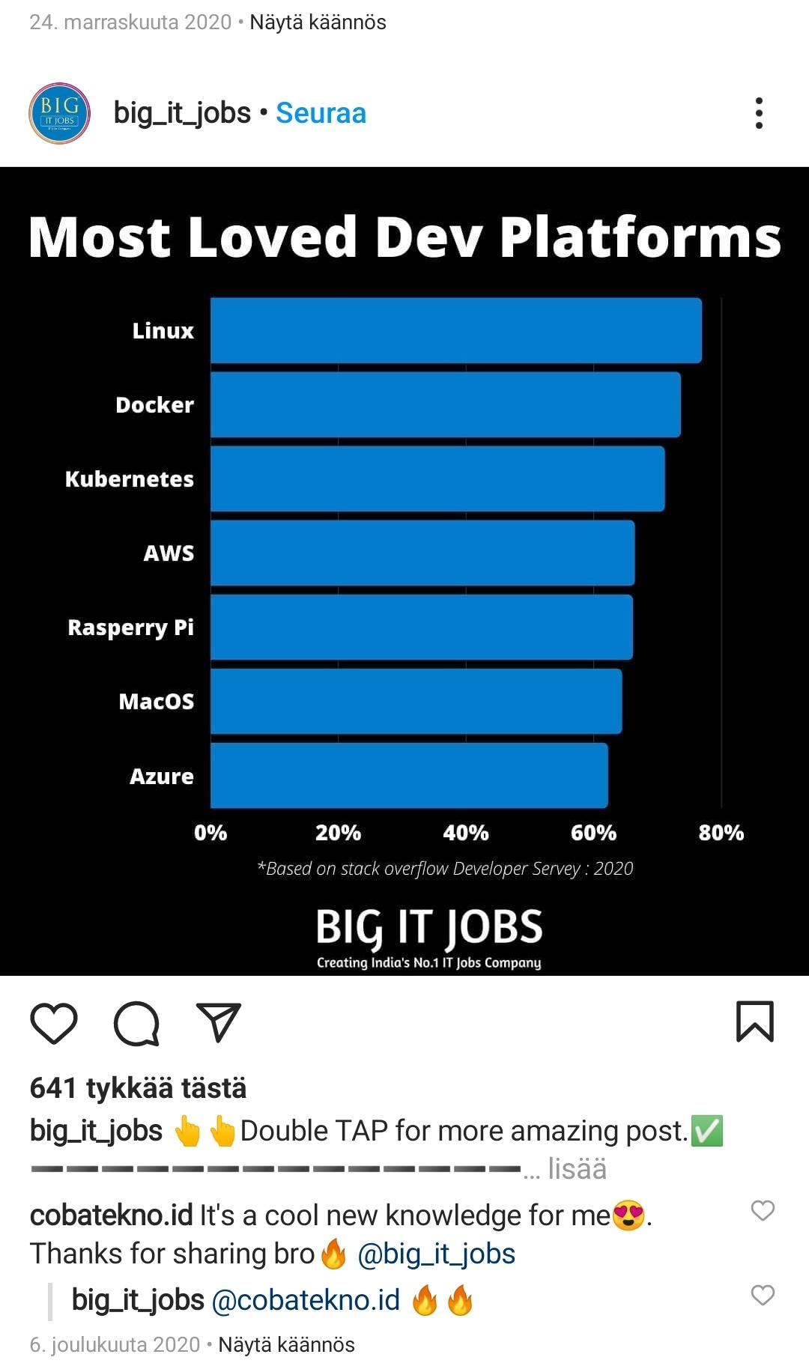

MOST LOVED DEV PLATFORMS:

Linux

Docker

Kubernetes

AWS

Raspberry Pi

MacOS

Azure

developerspace•Seuraa

Community

📍Promoting & sharing educative tips & resources from Devs.

📍Promoting & advertisements & sharing educative resources

BIG HTML CHEATSHEET 1/10 ↗️

BIG HTML CHEATSHEET 1/10 ➡️10/10

1/10

2/10

**Document Outline**

<!IDOCTYPE> Version of (X)HTML

<html> HTML Document

<head> Page Information

<body> Page Contents

📰

**Document Structure**

<h1>-<h6> Heading

<div> Page section

<span> Inline section

<p> Paragraph

<br /> Line break

<hr /> Horizontal rule

📑

**Page Information**

<base /> Base URL

<meta /> Meta

<title /> Title

<style> Style resource

<script> Script resource

ℹ️

**Links**

<a href=""> Page link

<a href="mailto"> E-mail link

<a href="name"> Anchor

<a href="#name"> Link to anchor

🔗⛓️

**Tabels**

<table> Table

<capture> Capture

<thread> Thread

<tbody> Table body

<tfoot> Table foot

<colgroup> Table Column group

<col /> Table column

<tr> Table row

<th> Table head cell

<td> Table cell

📰

**Forms**

<form> Form

<fieldset> Collection of fields

<legend> From legend

<table> Input label

<input /> From input

<select> Dropdown box

<textarea> Large input text

**<input type="checkbox"> Checkbox**

**<input type="radio"> Radio button**

**<input type="text"> Text input**

**<input type="submit"> Submit button**

**<input type="reset"> Reset button**

**<optgroup> Group of options**

**<option> Dropdown options**

**<textarea> Large input text**

**<button> Button**

BIG HTML CHEATSHEET 1/10↗️

HTML Cheatsheet ⅛

HTML Cheatsheet ⅜

HTML Cheatsheet ⅝

HTML Cheatsheet ⅞

BIG HTML CHEATSHEET 2/10↗️

HTML Cheatsheet 1/8

HTML Cheatsheet 2/8

HTML Cheatsheet 3/8

HTML Cheatsheet 4/8

HTML Cheatsheet 5/8

HTML Cheatsheet 6/8

HTML Cheatsheet 7/8

HTML Cheatsheet 8/8

BIG HTML CHEATSHEET 3/10↗️➡️

**Documents Outlines**

<!IDOCTYPE> Version of (X)HTML

<html> HTML Document

<head> Page Information

<body> Page Contents

BIG HTML CHEATSHEET 4/10↗️➡️

**Documents Structures**

<h1>-<h6> Heading

<div> Page section

<span> Inline section

<p> Paragraph

<br /> Line break

<hr /> Horizontal rule

HTML CHEATSHEET 6/10↗️ 5/10↗️➡️

**Links** **Links**

<a href=""> Page link

<a href="mailto"> E-mail link

<a href="name"> Anchor

<a href="#name"> Link to anchor

🔗🔗

HTML CHEATSHEET 6/10↙️➡️ 6/10↙️

**Page Information**

<base /> Base URL

<meta /> Meta

<title /> Title

<style> Style resource

<script> Script resource

BIG HTML CHEATSHEET 7/10↙️↙️➡️

**Tabels Tables**

BIG HTML CHEATSHEET 8/10 ↗️

<table> Table

<capture> Capture

<thread> Thread

<tbody> Table body

<tfoot> Table foot

<colgroup> Table Column group

<col /> Table column

<tr> Table row

<th> Table head cell

<td> Table cell

**Forms 1.0**

<form> Form

<fieldset> Collection of fields

<legend> From legend

<table> Input label

<input /> From input

<select> Dropdown box

<optgroup> Group of options

<option> Dropdown options

**Forms 1.0**

BIG HTML CHEATSHEET 8/10 ➡️

<form> Form

<fieldset> Collection of fields

<legend> From legend

<table> Input label

<input /> From input

<select> Dropdown box

<optgroup> Group of options

<option> Dropdown options

<textarea> Large input text

<button> Button

**<input type="checkbox"> Checkbox**

**<input type="radio"> Radio button**

**<input type="text"> Text input**

**<input type="submit"> Submit button**

**<input type="reset"> Reset button**

**Forms 1.0**

BIG HTML CHEATSHEET 9/10 ➡️

<form> Form

<fieldset> Collection of fields

<legend> From legend

<table> Input label

<input /> From input

<select> Dropdown box

<optgroup> Group of options

<option> Dropdown options

<textarea> Large input text

<button> Button

**Forms 1.0**

BIG HTML CHEATSHEET 10/10 ➡️

<form> Form

<fieldset> Collection of fields

<legend> From legend

<table> Input label

<input /> From input

<select> Dropdown box

<optgroup> Group of options

<option> Dropdown options

<textarea> Large input text

<button> Button

Forms 1.02

Forms 2.01

<input type="text"> Text input

<input type="submit"> Submit button

<input type="reset"> Reset button

<input type="radio"> Radio button

<input type="checkbox"> Checkbox

Forms 1.0

BIG HTML CHEATSHEET 1./10 ➡️

**Lists**

New, old:

<ol> OrderList

<ul> UnorderList

<li> List item

<dl> Definition List

<dt> Definition term

<dd> Term description

BIG HTML CHEATSHEET 2./10 ➡️

**Forms**

New, old:

<form> Form

<fieldset> Collection of fields

<legend> From legend

<table> Input label

<input /> From input

<select> Dropdown box

<optgroup> Group of options

<option> Dropdown options

<textarea> Large input text

<button> Button

pwd

mkdir dir

cd dir

cd..

ls

touche *file1*

touche *file2*

cat *file1* *file2*

cat *file2*

cp *file2* *file1*

cp *file1* *file2*

mv *file1* *file2*

rm *file1*

mv *file1*

grep pattern files

find /dir/ -name name*

whereis *command*

locate *file*

chmod -R 775 *folder1*

chmod -R 600 *folder1*

chmod 775 *file1*

chown user:group *file*

uname -a

head -n1 /etc/issue

mount

whoami

man command

ip addr show

whois domain

dig domain

hostname -l

wget *file*

df -h See free and used space on mounted systems

fdisk -l Display disc partitions, sizes and types

du -ah -sh See disc usage du for all files

du -ah See du for all files and directory

du -sh See du for the current directory

mount device_path mount_point Mount a device

yum install package_name.rpm Install a package using the YUM **yum**

dnf install package_name.rpm Install a package using the DNF **dnf**

apt -get install package_name.rpm Install a package using the APT **apt**

rpm -i package_name.rpm Install local Package *Package_name.rpm*

rpm -e package_name.rpm Remove local file